***School Parent Involvement Policy and Plan for Shared Student Success***

***2015-2016***



***MILES INTERMEDIATE***

***Ms. Thalise Perry***

***4215 Bakers Ferry Rd.***

***404-802-8900***

***http://www.atlanta.k12.ga.us/Domain/674***

***Revised: 10/2/15***

***What is Title I?***

Miles Intermediate is identified as a Title I school as part of the Elementary and Secondary Act of 1965 (ESEA). Title I provides financial assistance to local educational agencies (LEAs) and schools with high numbers or high percentages of children from low-income families to help ensure that all children meet challenging state academic standards. 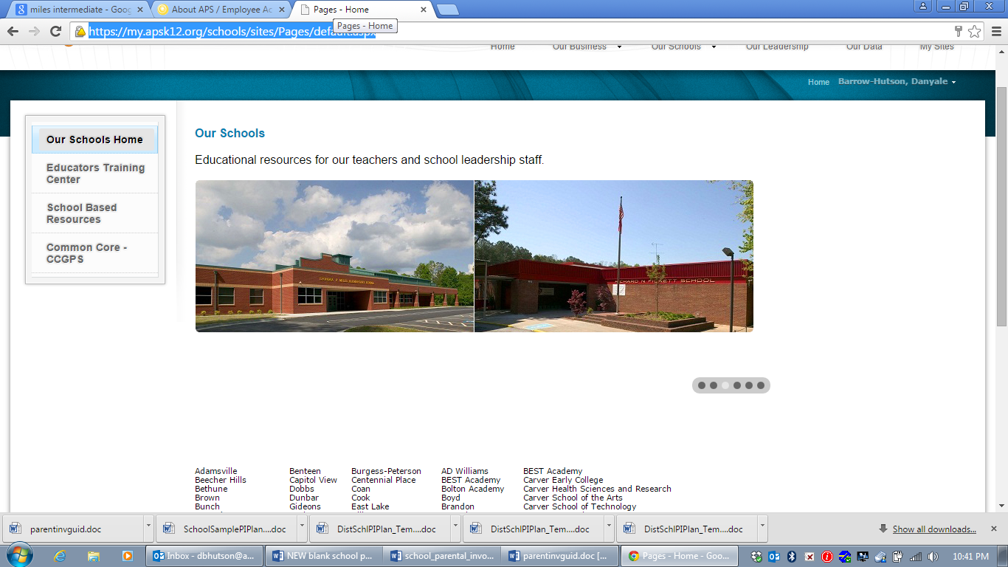

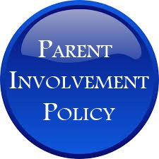 **School Plan for Shared Student Achievement**

***What is it?*** This is a plan is a local development of parental involvement plans with sufficient flexibility to address local needs, and building parents’ capacity for using effective practices to improve their own children’s academic achievement. Miles Intermediate wants to provide a nurturing, comprehensive, and high performing school where faculty, staff, parents, and all stakeholders will jointly prepare our students to become globally productive citizens and leaders.

***How is it developed?*** Miles Intermediate will reach out to parents to get their input about the plan which is revised annually. Parents will have an opportunity to complete surveys online or sent home at least three times during the school year so that their suggestions can be addressed with school leaders to revise the plan for the upcoming school year.

***Who is it for?*** All students participating in the Title I, Part A program, and their families, are encouraged and invited to participate in the parent involvement opportunities. Miles Intermediate welcomes all families to events, workshops, and activities.

***Where is it available?*** Once the plan is developed, it will be distributed, posted on the school website, posted in the parent center and main office, and also made available at all Title I meetings, workshops, and events.

**2015-2016 District Goals:**

Develop an academic program that our students will be well-rounded individuals who possess the necessary academic skills and knowledge and are excited about learning

**2015-2016 Miles Intermediate Goals:**

This compact pledges our school family to increase student academic achievement performance in the areas of Science, Social Studies, Math, and Literacy in order to show an increase in our school CCRPI Score. Our goal is to move from a 47.2 to 60 CCRPI Score.

Miles’ goals from School Wide Plan are as follows:

• Based on previous state test scores, we are focusing on increasing student achievement points in the areas of ELA, Math, Science, and Social Studies by 4%.

• Miles Intermediate will provide additional academic support for our students that are falling into our lowest 25% of academic performance in the areas of Math and Literacy in order to close the academic achievement gap.

**Let’s Get Together!**

**Miles Intermediate** will host the following events to build the capacity for strong parental involvement to support a partnership among the school, parents, and the community to improve student academic achievement

**CALENDAR:**

|  |  |  |  |
| --- | --- | --- | --- |
| **Mon., Aug. 3, 2015** | ***Parent Center OPEN HOUSE*** | **Auditorium & Parent Center** | **5pm-7pm** |
| **Fri., Aug. 14, 2015** | ***School Wide Planning & Meet & Greet Classroom Observations*** | **Parent Center & Grade Level Classrooms** | **10am-11:30am** |
| **Wed., Aug. 19, 2015** | ***3rd Grade Curriculum Night/ Title I Meeting*** | **Homerooms** | **5pm-7pm** |
| **Wed., Aug. 26, 2015** | ***4th Grade Curriculum Night/ Title I Meeting*** | **Homerooms** | **5pm-7pm** |
| **Wed., Sept. 2, 2015** | ***5th Grade Curriculum Night/ Title I Meeting*** | **Homerooms** | **5pm-7pm** |
| **Fri., Sept. 25, 2015** | ***Adventures in Reading & Writing*** | **Media Center** | **12pm-2pm** |
| **Tues., Oct. 20, 2015** | ***Morning Parent Talks Semester Unit Review*** | **Grade Level Rotations/**  **Band Room** | **9am-10:30am/**  **6pm-7:30pm** |
| **Mon., Nov.2-Fri., Nov. 6, 2015** | ***Parent Engagement Week*** | **Parent Center** | **9am-1pm** |
| **Tues., Jan. 12, 2016** | ***“What does My Child’s Progress Look Like for the New Year?”***  ***-Review Progress Reports*** | **Miles Media Center** | **6:00pm-7:30pm** |
| **Fri., Jan. 29, 2016** | ***Techno-Learning in the Classroom*** | **Miles Media Center** | **11am-12pm** |
| **Feb. 3-, 10, 17, 24-March 2, 9, 16, 23, 30, 2016**  **Wednesdays** | ***Academic Wednesday Workshops for Working Parents*** | **Parent Center Room** | **10am-11am or**  **3pm-4pm** |
| **Fri., March 4, 2016** | ***Miles Parent Center Spring***  ***Open House*** | **Miles**  **Auditorium** | **9am-noon/ 1pm-3:30pm** |

\****Future dates will be posted on social media, texting/phone messaging, and flyers.***

**Future Events will be posted on the schools website, and announced through take home flyers, email, text, and voice messenger.**

**School-Parent Compacts**

As part of this plan, **Miles Intermediate** and our families will develop a school-parent compact. It is an agreement that explains how parents, teachers and students work together to make sure all our students reach grade-level standards.

The compacts are reviewed and updated annually based on the feedback from parents, students and teachers during the School-Wide Planning meeting.

Parents and teachers worked diligently to create compacts specifically for each grade level. A copy of the school-parent compact brochure is distributed to every family to use during the year.

**Parental Involvement**

**Miles Intermediate** believes that parent involvement means the participation of parents in regular two-way, and communication involving student academic learning and other school activities, including ensuring –

* That parents play a role in assisting their child’s learning;
* Parents are encouraged to be actively involved in their child’s education at school and home.
* That parents are full partners in their child’s education and are included in decision-making and on advisory committees to assist in the education of their child.
* The carrying out of other activities as described in this plan.

**Neglected and Delinquent Statement**

* If students are being educated at LEA schools, the LEA schools' parental involvement plan must include a statement that the residential facilities in its school attendance area are included in the parental involvement correspondence and activities.

**Miles Intermediate** is committed to helping our parents attend the parental activities listed in this plan. Please call or email us if you need assistance with childcare or transportation, or interpreter in order to participate in our programs.

**404-802-8900 (Main Office)**

**404-802-7580 (ESOL Department)**

**Parent Involvement Standards**

**Miles Intermediate** and our parents have adopted the National PTA Standards for Family-School Partnerships as the school’s model in engaging parents, students, and the community. These standards are –

*Welcoming All Families *Communicating Effectively *Supporting Student Success

*Speaking Up for Every Child *Sharing Power *Collaborating with Community

**Miles Intermediate is Branching Out!**

**Miles Intermediate** will take the following measures to promote and support parents as an important foundation of the school in order to strengthen the school and reach our school goals.

We will:

* Provide parents with timely information about Title I workshops and information sessions, school events, parent involvement activities, local school councils, PTA meetings, and Principal Coffees.
* Communicate with all families and the community on a regular basis through phone messages, social media, flyers and face-to-face interactions.
* Share information in English and Spanish at workshops, meetings, and conferences, as well as provide interpreters upon request.
* Provide necessary materials and handouts for parents to help parents work with their child to improve their child’s academic success.
* Provide monthly training to staff on strategies to improve communication with parents and ideas to increase family engagement.
* Explain curriculum, the forms of assessments, Lexile rankings, expectations, and school policies once per semester so parents are aware of their child’s progress.
* Work with parents to develop relevant trainings and helpful presentations to educate staff and families on the importance of a school-home connection and parent involvement.
* Collect feedback from parents at all events and throughout the year in order to respond to parents’ requests.

**School Community Team**

**Miles Intermediate** invites **ALL** parents to join the Title I Parent Involvement Committee to share ideas and ways to involve other parents to build partnerships with school, families, and the community. The team will meet during the school year, but parents can also submit their ideas or suggestions during all activities and meetings as well as through our parent surveys and website. If you would like to learn more about the Title I Parent Involvement Committee please contact Parent Liaison, Ms. Barrow-Hutson at [dbhutson@atlanta.k12.ga.us](mailto:dbhutson@atlanta.k12.ga.us) or complete the appointment/interest form and leave it in the Main Office.

**Parental Involvement Committee**

* Yes, I am excited about joining the PIC
* Yes, please contact me so I can learn more about the PIC
* Yes, this sounds like a great idea, please keep me posted about future meetings

Name: ____________________________________________________________

Child’s Name and Grade: ________________________________________

Email Address: __________________________________________________________

Phone Number: __________________________________________________

Email address: ____________________________________________________



 

**Parent Center Information**

Miles Intermediate Parent Center is open Monday-Friday 7:30am-3:30pm, extended hours available upon request.

Parent Liaison, Ms. Danyale Barrow-Hutson, can be reached by phone 404-802-8919 or by email [dbhutson@atlanta.k12.ga.us](mailto:dbhutson@atlanta.k12.ga.us)

**Share Your Thoughts**

We want to hear from you. If you have any suggestions or if there is any part of this plan that you feel is not satisfactory with the students’ and the school’s goals for academic achievement, please provide us with your comments in the space provided and leave this form in the Main Office:

Name: (optional) _______________________________________________________________________________

Telephone Number: (optional) _________________________________________________________________

________________________________________________________________________________________________________________________________________________________________________________________________________________________________________________________________________________________________________________________________________________________________________________________________________